Image: Peter Morgan (CC Non Commercial Use)

A petition to <YOUR COUNCIL> to adopt a

CLIMATE EMERGENCY DECLARATION

with an immediate action plan.

Created by Sustainable Wales as a community resource.
http://www.sustainablewales.org.uk/

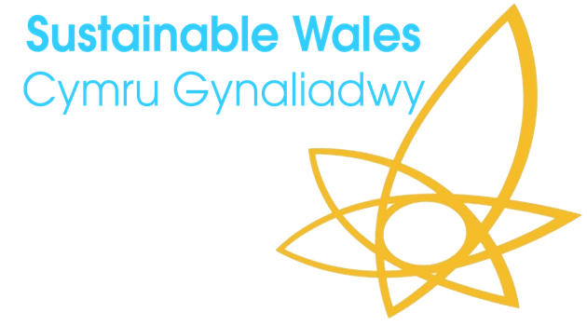
Please make use of this, adapt for your Council, sign our petition ( here ) and share widely.
For the attention of:
COUNCIL Chief Executive ………., and Leader Cllr………….
In light of increasing public concern regarding climate change and the escalating emergency we urge all local councils to reshape their public policies accordingly.
We do not need to wait for national governments, indeed a growing number of local authorities have already passed ‘climate emergency’ motions.
We look forward to your reply.
Yours sincerely

CONTEXT: The IPCC Report

The Intergovernmental Panel on Climate Change (IPCC) released a special report in October 2018 on the subject of ‘Global Warming of 1.5°C’. The report is an international effort led by the endangered low-lying island states of the Pacific, to summarise the current scientific consensus on how society might limit global warming to 1.5 degrees, as well as the likely life-threatening consequences of greater levels of warming. The report states that:

- Human activity has already caused 1°C of warming to the earth.

- To limit warming to 1.5°C it will be necessary to halve global carbon emissions by 2030 and to achieve near-zero net emissions by 2050.

- The consequences of 2°C warming are significantly worse than 1.5°C warming across all areas considered in the report.

At present, political leaders are falling far short of delivering the action necessary to limit warming to 2°C.
The likely global failure to achieve this target will result in increasingly severe consequences including large scale water and food shortages, widespread flooding, heat related morbidity, the large-scale destruction of the natural world including agricultural capacity, and substantial political and economic instability.
These changes are already in progress.
The media attention around climate change activist Greta Thunberg, the school strikes for climate, the Extinction Rebellion movement, https://rebellion.earth/the-truth/demands/ and David Attenborough’s BBC programme, “Climate Change – The Facts” have had a galvanising effect.
People from all walks of life, especially younger people, are waking up to the disturbing immediacy of the climate emergency, and of the urgent need for action.
Pressure on governments is increasing. In May 2019, the Senedd took the decision to declare a Climate Emergency in Wales adding to the growing list of towns and cities internationally.
Some councils have specifically stated they want their authority to be carbon neutral by 2030. (Machynlleth was the first in Wales https://www.bbc.co.uk/news/uk-wales-46961053)
On June 11th the Welsh Government declared it would seek to achieve net-zero carbon emissions by 2050. The former UK Prime Minister Theresa May, did announce a similar intention for the UK, and said it is now "time to go further and faster to safeguard the environment for our children.”
The fact is that the climate emergency is not something that will only happen to future generations. It is happening right now, it is happening to us now, and to have any chance of mitigating its most severe effects, we must take notice and must act now.
Business as usual is not an option.
The key question we must ask ourselves is this:
Are we planning for a realistic future, one that must be carbon neutral, renewable and sustainable? Or are we still living in the past, and planning for a carbon-based, consumerist and high waste economy?

CLIMATE EMERGENCY DECLARATION

…………… group urges town, community and the county council across the County Borough to take a lead and declare a "Climate Emergency" joining the numerous pioneering councils across Britain that have done this already.

Suggestions for what a Climate Emergency declaration might contain, include:
…Council notes:
- That the impacts of climate breakdown are already causing serious damage around the world and in Wales we have also had impacts… https://www.theguardian.com/environment/2019/may/18/this-is-a-wake-up-call-the-villagers-who-could-be-britains-first-climate-refugees
- That the ‘Special Report on Global Warming of 1.5°C’, published by the Intergovernmental Panel on Climate Change in October 2018, Special Report (a) describes the enormous harm that a 2°C average rise in global temperatures is likely to cause compared with a 1.5°C rise, and (b) confirms that limiting Global Warming to 1.5°C may still be possible with ambitious action from national and sub-national authorities, civil society and the private sector.
- That all governments (national, regional and local) have a duty to act, and local governments that recognise this should not wait for their national governments to change their policies.
- That strong policies to cut emissions also have associated health, wellbeing and economic benefits.
- That, recognising this, a growing number of UK local authorities have already passed 'Climate Emergency' motions.
…Council therefore commits to:
- Declare a ‘Climate Emergency’ that requires urgent action.
- Make the Council’s activities net-zero carbon by 2030 and we start now.
- Ensure that all strategic decisions, budgets and approaches to planning decisions are taken with a view to reducing carbon emissions as soon as possible and certainly in line with a shift to zero carbon by 2030.
- Support and work with all other relevant agencies towards making (e.g.: Council) ‘Zero Carbon’ within the same timescale.
- Achieve 100 per cent clean energy across (e.g.:Council)’s full range of functions by 2030.
- Request that Council Scrutiny Panels consider the impact of climate change and the environment when reviewing Council policies, management systems and strategies.
- Report on the level of investment in the fossil fuel industry that our pensions plan and other investments have reached, and review the Council’s investment strategy to give due consideration to climate change impacts in the investment portfolio.
- Convene a citizens’ assembly in 2020 to oversee and feed into the development of related action plans and budgets, taking steps to proactively include young people in the process, ensuring that they have a voice in shaping the future.
- Call on the UK Government to provide the powers, resources and help with funding to make this possible, and ask local MPs to do likewise;
e.g. Consider actions that could be implemented, including (but not restricted to): renewable energy generation and storage, providing electric vehicle infrastructure and encouraging alternatives to private car use, increase public transport and also active travel schemes increasing the efficiency of buildings, in particular to address fuel poverty; responding also to biodiversity requirements; proactively using local planning powers to accelerate the delivery of net carbon new developments and communities, coordinating a series of information and training events to raise awareness and share good practice.
We are at a truly historic moment. The decisions we make will have a tremendous impact, for good or ill, on the society of tomorrow. It is vitally important that we all take our part to ensure that our children and our grandchildren can enjoy healthy and fulfilling lives, in a stable and sustainable world. We can achieve this if we take the necessary action today.

